Next Gen Program Recipient: Duley Farms
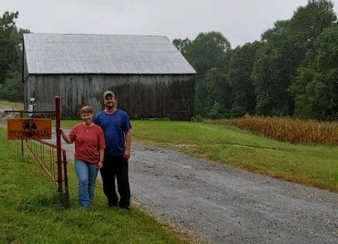
Farming is often passed down through generations, and this is true for the Duley family. In 2013, Paul Duley, and his wife Missi, took over his father’s farming operation, Duley Farms. It is comprised of 2,000 acres, which are mostly leased and in Prince George’s and St. Mary's Counties. Their home farm is in Upper Marlboro in Prince George’s County. Their primary crops are grains, including corn, soybeans, wheat, and sorghum.

“I have been farming my whole life,” says Paul. “My father was a farmer up until about five years ago when he was forced to retire due to medical reasons. I had to take over the farming operation and decision-making.” Paul heard about MARBIDCO through his local USDA Farm Services Agency (FSA) office. He decided to apply to the Next Gen Program because it has been difficult to figure out how to afford to purchase a farm. The farm he purchased also had sentimental value.

“It was my grandparent’s farm, is centrally located, and has on-site grain storage,” said Paul. “The expense of buying a different location and moving everything was just too great.” According to Paul, the Next Gen Program was a win-win for him and his family as well as the public.

“MARBIDCO assisted us greatly by providing the funds to allow us to purchase the farm and still be able to afford all the expenses of farming,” said Paul, “by not having a huge down payment and reducing our monthly loan payment. It was always our intention to have the land preserved; we just weren't sure how to afford the payments until preservation went through.”

In the future, Paul says they plan to expand the grain storage they have on their farm. They also want to expand their business into selling bagged grain for animal and wildlife feed and to have a grain handling set up where they will be able to buy grain from local farmers as well.

